Essence of RASA NLU

This article mainly describes more about

So, What is Rasa NLU?

Rasa is Open source conversational AI. NLU in Rasa stands for Natural language understanding. Confused between NLP -NLU well NLP is short for Natural Language Processing while NLU is short from of Natural Language Understanding. Both share a common goal of understanding the interaction between natural language: as in human speak (English) and computer. Rasa NLU is natural language processing tool for intent classification, response retrieval, entity extraction and many more. It is specially used to identify sentiments, conversational chatbots, named-Entity Recognition and identifying the purpose of sentence (intent).

Objective

In this article, we are going to build an intent classification model which will understand user provided intents and classify sentences accordingly. Rasa pipeline are mainly developed for chatbot understanding but we are tweaking it so as to get desired result

Prerequisites and dependencies

Anaconda (recommended)

Python 3.6

Rasa 1.0.6

Visual C++ Build Tools

Node.js

Tensorflow

When you install Rasa, dependencies may vary according to pipeline you use.

Since we are going to identify intent we will use tensorflow pipeline provided by Rasa.

Link- <https://github.com/RasaHQ/tutorial-tf-pipeline>

Or

You can use this repository and install Rasa:

pip install rasa-x --extra-index-url https://pypi.rasa.com/simple

$ pip install rasa[spacy]

$ python -m spacy download en_core_web_md

$ python -m spacy link en_core_web_md en

This will install Rasa NLU as well as spacy and its language model for the English language (en).

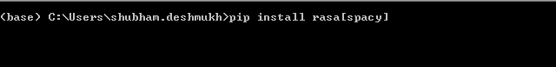

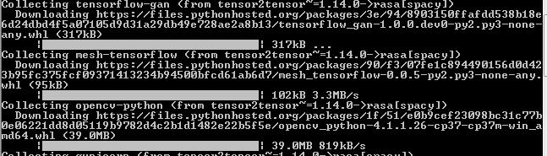

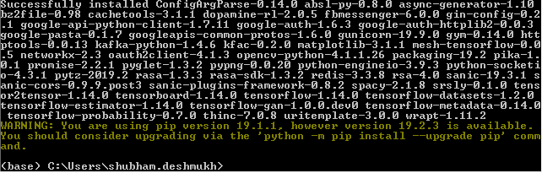

Anatomy of Tensorflow Pipeline for intent identification

1. **data/nlu.md**: Your NLU training data
2. **data/stories.md**: Your stories
3. **domain.yml**: Your assistant’s domain
4. **Readme.**md: Instruction file
5. **config.yml**: Configuration of your NLU and Core models

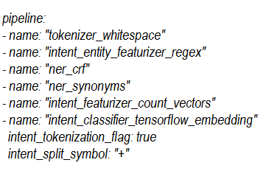

Time to Prepare the Training Data (data/nlu.md)

We need to store training data in markdown file.

The training data consists of a list of messages in the form text

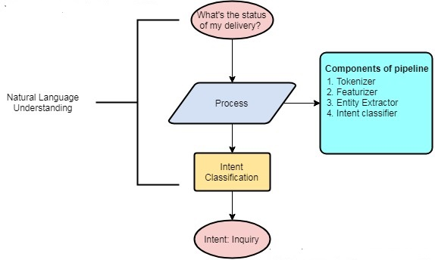

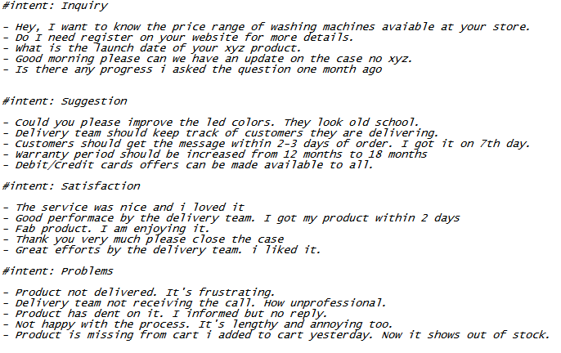

Now we will train our data



Testing time

import rasa_nlu

import rasa_core

from rasa_nlu.model import Metadata, Interpreter

interpreter=Interpreter.load('models/current/nlu_model')

interpreter.parse("I don't like you product take it back")

interpreter.parse("I would request to add my number in the list")

interpreter.parse("I really like your product. It's superb")

interpreter.parse("What is the date for my product delivery")

#intent: Inquiry

- Hey, I want to know the price range of washing machines available at your store.

- Do I need to register on your website for more details?

- What is the launch date of your xyz product.

- Good morning can we you please update the case no as completed.

- Is there any progress on my current product?

#intent: Suggestion

- Improve the led colors. They look old school

- Delivery team should keep track of customers they are delivering.

- Customers should get the message within 2-3 days of order not 5-7 days.

- Warranty period should be increased from 12 month to 18 months.

- Debit/credit cards offers can be made available to all.

#intent: Satisfaction

- The service was nice and i loved it.

- Good performance by the delivery team. My flat was on top floor.

- Fab product. I am enjoying it.

- Thank you very much for fast delivery.

- Great efforts. I issue got resolved within two days.

#intent: Problems

- Product not delivered.It's frustrating.

- Delivery team not receiving the call. How unproffesional

- Product has dent on it. I informed but no reply. Cheap service.

- Not happy with the process. It's too lenghtly and tedious

- Product is missing from the cart. I added to cart few hours ago. It's annoying.